DBMS LAB # 4
- QUERY:
SELECT Job, AVG (BasicSalary) AS AvgSalary
FROM teacher
GROUP BY Job
OUTPUT:
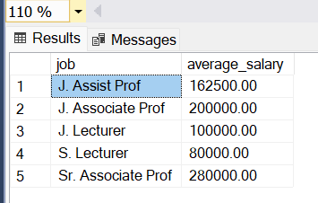
- QUERY:
SELECT Job, MAX(Slaary) AS MaxSal, MIN(BasicSalary) AS MinSal
FROM Emp
GROUP BY Job

OUTPUT:
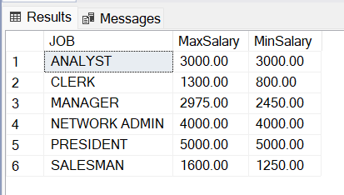

- QUERY:
SELECT Job AS “Job Title” FROM Emp
GROUP BY Job
HAVING AVG(Sal + isnull(COMM,0))>1800
OUTPUT:

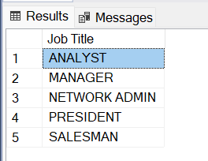

- QUERY:
SELECT COUNT(*) FROM teacher
WHERE houserent is null
OUTPUT:

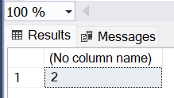

- QUERY:
SELECT Job AS “Designation”, MAX(BasicSalary) AS”Max Salary” FROM teacher
GROUP BY job
HAVING MAX(BsicSalary)> 200000
ORDER BY MaxSalary desc
OUTPUT:
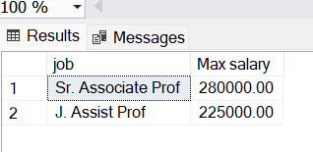

- QUERY:
SELECT Job, COUNT(*) AS FacultyCount
FROM teacher
WHERE Job = ‘J. Lecturer’
GROUP BY Job;
OUTPUT:
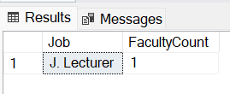

- QUERY:
SELECT EName, Sal,
FORMAT(HIREDATE,’MM DD YYYY’ ) AS FormattedDate
FROM Emp
WHERE HireDate < December 31, 1983’
OUTPUT:
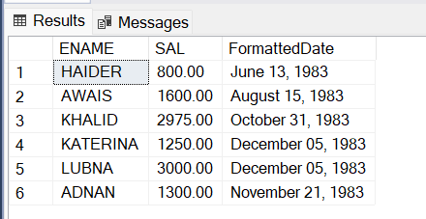

- QUERY:
SELECT Job AS JobTitle, COUNT(*) AS NoOfEmp,
FORMAT(AVG(Sal + isnull(comm,0)),’N2’) AS AvgSalary
FROM Emp
GROUP BY Job
OUTPUT:
